# UNIVERSITY OF MUMBAI PRACTICAL ON

user interface

# SUBMITTED BY

**DALVI TEJAS RAJENDRA**

**Application Id - 170021**



# D.T.S.S. College of Commerce

# Subject Faculty Name

# Mrs. Divya Kishore

**MCA I [2022-23]**



## UNIVERSITY OF MUMBAI

**INSTITUTE OF DISTANCE AND OPEN LEARNING (IDOL)**

## CERTIFICATE

THE EXPERIMENTS DULY SIGNED IN THIS PROJECT REPORT REPRESENT THE BONAFIDE WORK BY Mr**. DALVI TEJAS RAJENDRA** APPLICATION ID / SEAT NO. **170021** IN **SEMESTER 2** OF **FIRST YEAR OF MASTER OF COMPUTER APPLICATION (FYMCA 2YRS)** OF PCP CENTER **DTSS COLLEGE MALAD (EAST)** FOR **USER INTERFACE** DURING THE ACADEMIC YEAR 2022-2023.

## LECTURE IN CHARGE HEAD OF DEPARTMENT COURSE IN CHARGE

**Examiner**

**Date:**

## DTSS College Seal

INDEX

|  |  |  |  |
| --- | --- | --- | --- |
| Sr.No. | Topic Name | Page No. | Remarks |
| 1. | Study of UI life cycle and UI tools | 4 |  |
| 2. | Requirement Gathering – Flow Chart | 5 |  |
| 3. | Analysis – ER Diagram ATM Transaction | 6 |  |
| 4. | Class Diagram for ATM Transaction | 7 |  |
| 5. | User Scenario | 8 |  |
| 6. | User Story | 10 |  |
| 7. | Prototyping Low Fidelity prototype (Hand sketch)  Flight Booking | 12 |  |
| 8. | Prototyping - High Fidelity prototype | 13 |  |
| 9. | Calculator using Figma | 15 |  |

Practical 1: Study of UI life cycle and UI tools

1.Mockflow

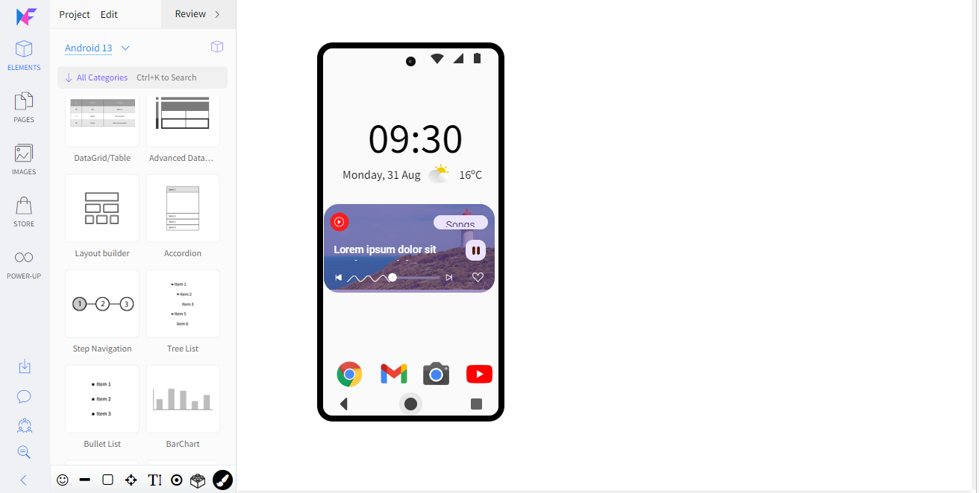

2.Balsamiq

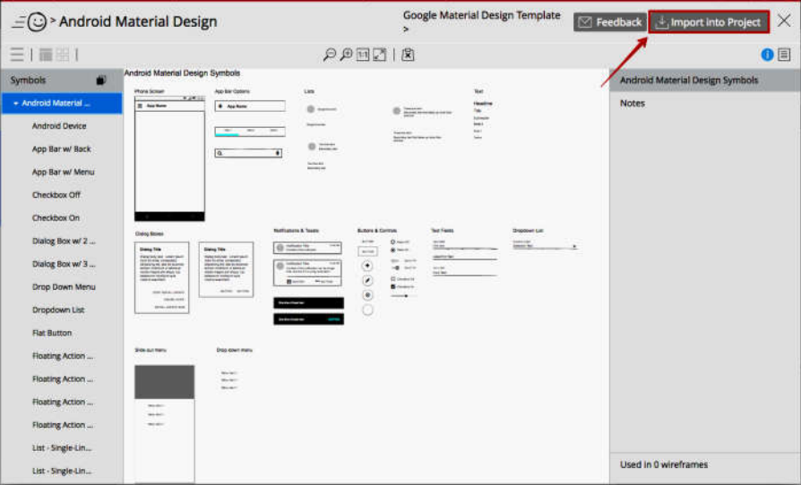

Practical 2: Requirement Gathering – Flow Chart

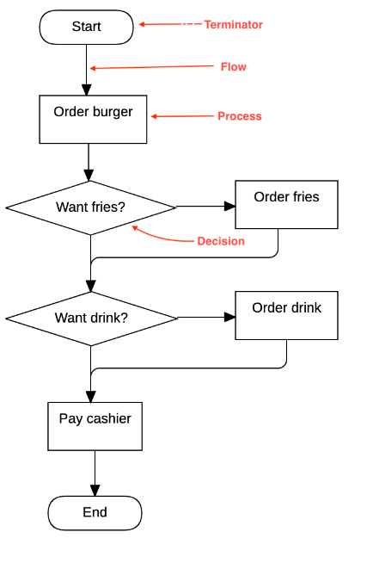

Practical 3 : Analysis – ER Diagram ATM Transaction

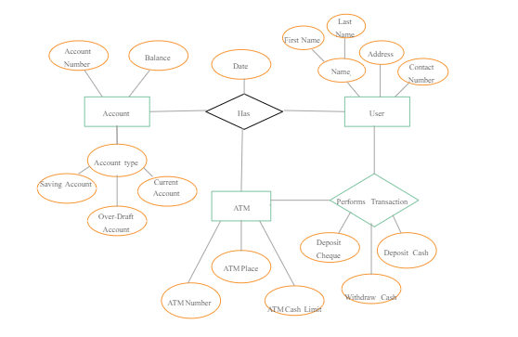

Practical 4 : Class Diagram for ATM Transaction

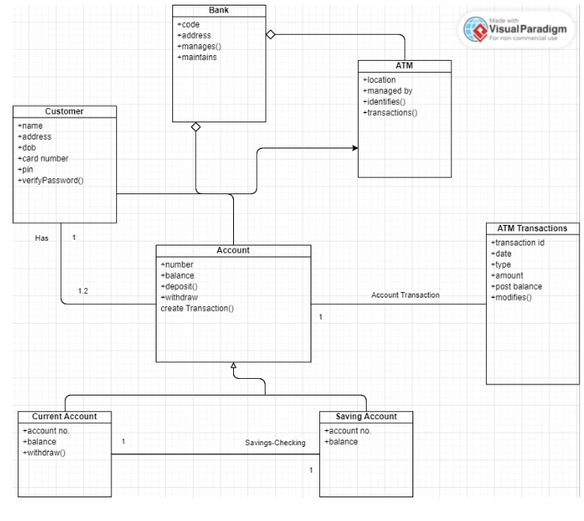

**Practical 5 : User Scenario**

2. OVERALL PRODUCT DESCRIPTION

2.1 PRODUCT PERSPECTIVE

The Airline Reservation System project uses the .NET framework 1.1 and is completely independent. The project itself is a bigger product and does not need to be introduced into a larger system. The application would be running on a Windows XP/2000 Operating system

2.2 PRODUCT FEATURES

The Airline Reservation System has the following features: This project is mainly intended for two types of audiences. One is the customer or the end user and the other is the administrator of the website. Some of the major functions of the product can be categorized under two different categories that are for the administrator and the user.

2.2.**1 Customer / End user activities** Figure 1 - Customer use case diagram

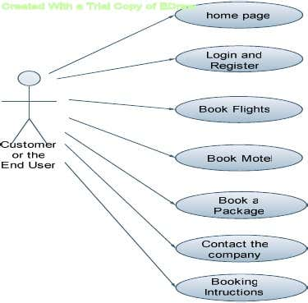

The above use case diagram depicts all the functions or activities that a user or a customer can perform on the application. They can be discussed in detail as follows:

**Home Page:**

 Like all the other airline websites available online, the user can access the user home page of the Airline Reservation System website, after he logs into the system.Here, he can look up information regarding flights, packages and motels.

**Login and Register:**

The Airline Reservation System also comes with the customer registration details page, where the customer can enter his details and register. He can also create a username and password. Moreover, he will also be able to modify the registration information in case of a change in his e-mail address or any other information.

Booking Flights:

The customer can also search for the flights available and reserve his place on the flight by purchasing a ticket.

**Book Motels:**

Different Airline websites like Orbitz also offer various deals for booking Motels along with the airline tickets. So, the customer will also be able to view this functionality on the website.

**Book Packages:**

This functionality is similar to the motel booking function, except the fact that the customer can look up various touring packages available at the person’s destination.

Contact the Company:

The Customer can also call the company if he has any concerns or questions related to the bookings he has made online.

**Booking Instructions:**

The website also provides instructions to the customers on how to book airline tickets or motels along with the different packages. Some of the functions of the Airline Reservation System, such as creating, maintaining and updating the database are available only to the administrator. The functions of the administrator, explained in detail are as follows:

**Administrator Activities Login/Logout:**

The administrator has to login first in order to be able to make changes to the Airline Reservation System, by adding, deleting or modifying the data in the Airline Reservation System database. After making the necessary changes, he then has to logout of the system, in order to prevent misuse of the data.

**Add/Modify Customer Information:**

Daily the Airline Reservation System will have many customers registering with the website and many of them unsubscribing. Only the administrator will have the sole rights to modify the database accordingly.

**Add/Modify Flight Information:**

The Administrator also has the sole rights to add, delete or modify the flight information. Sometimes, flights get cancelled for some reason, so such flights would be removed from the list of flights available to the customer. Similarly whenever any flight information has to be modified or if any new flights need to be added to the database, these operations are performed by the administrator.

**Add/ Modify Motel Information:**

The administrator can also add/delete or modify information related to different motels. This information can be the number of rooms available at the motel, the prices etc.

**Cancellation of Reservations:**

Sometimes, after making a reservation, a customer might cancel the reservation he has made. So, the administrator also handles such special situations and sends the customer an e-mail confirmation after deleting the specific transaction.

**E-mail confirmations:**

Whenever a customer makes or cancels a reservation, the administrator is responsible for sending confirmation e-mails to the customer, confirming the transaction

Practical 6 : User Story

1. As a Customer

I want to **Login** to my account using card and PIN code So that I can perform the transactions.

Acceptance Criteria -

• System must validate the card and pin code

• In case Customer enters wrong Pin code three times then the system locks the card.

2. As a Customer

I want to **check the balance** of my bank account So that I can perform transactions.

Acceptance Criteria -

• Customer needs to be logged in before checking balance.

• Balances is displayed.

3. As a Customer

I want to **deposit cash** in my bank account through ATM

So that I may save my time and perform transactions later.

Acceptance Criteria -

• Customer needs to be logged in before depositing cash.

• System should verify the amount of cash deposited by checking with the user.

• If the user doesn’t agree then the system ejects back the cash.

• If Ok the account balance is updated and displayed.

4. As a Customer

I want to **deposit check** in my bank account through ATM

So that I may save my time and perform transactions later.

Acceptance Criteria -

• Customer needs to be logged in before depositing check.

• System should verify the amount written on the deposited check by asking the user.

• If the user doesn’t agree then the system ejects back the check.

• If Ok the account balance is updated and displayed.

5. As a Customer

I want to **withdraw cash** from my bank account through ATM So that I may save my time.

Acceptance Criteria -

• Customer needs to be logged in before withdrawing cash.

• System checks to see if the request amount exceeds the balance

• If so the system displays the balance and asks the user to enter a new amount.

• If amount entered is less than the account balance cash is dispensed and the new

balance is displayed.

6. As a Customer

I want to **transfer money** from my account to another bank account through ATM So that I may save my time.

Acceptance Criteria -

• Customer needs to be logged in before transferring amount.

• System should check the receivers account number and validate it prior to performing the transactions.

• If Ok the local account balance is updated and displayed.

• System should update both accounts concurrently.

7. As a Customer

I want to **logout** from my bank account through ATM So that I may end up my ATM session.

Acceptance Criteria -

• System asks user if the user wants session report and receipt for the entire session.

• If yes then the receipt is dispensed

• User is logged off from the account

Practical 7: Prototyping Low Fidelity prototype **(Hand sketch)**

Flight Booking

Practical 8: Prototyping - High Fidelity prototype

1. Flight Booking

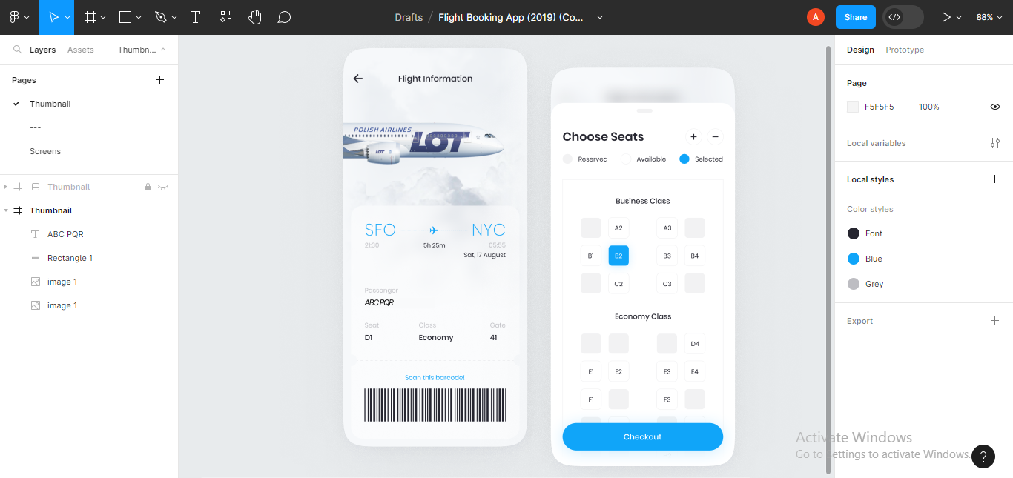

1. IRCTC App

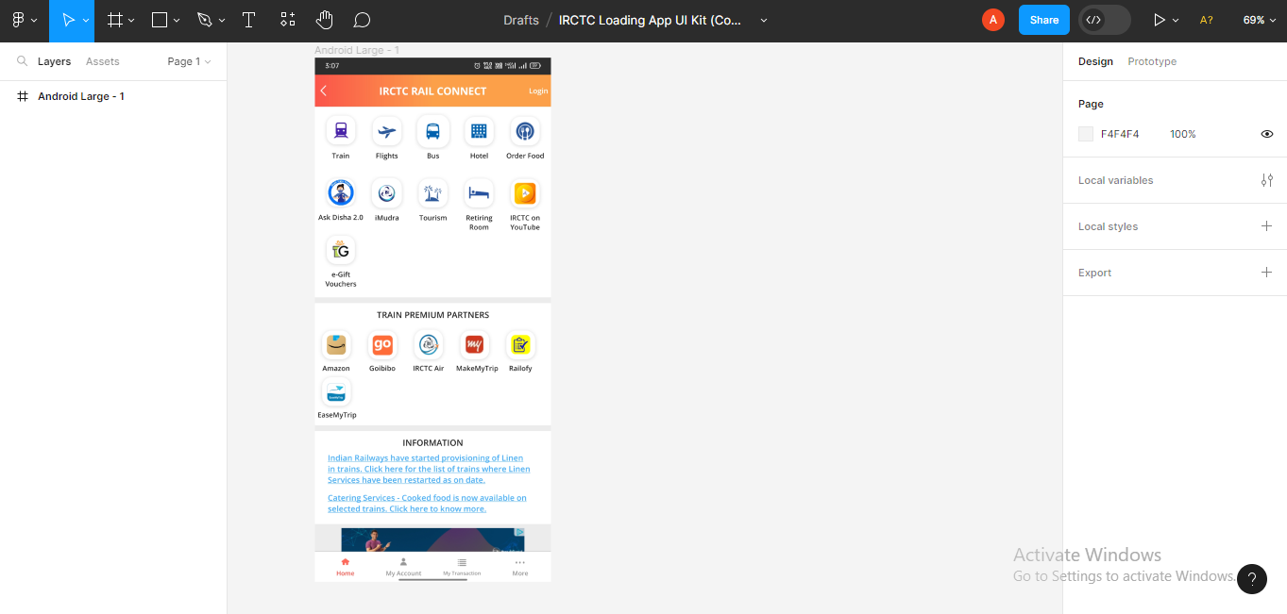

1. ATM Machine

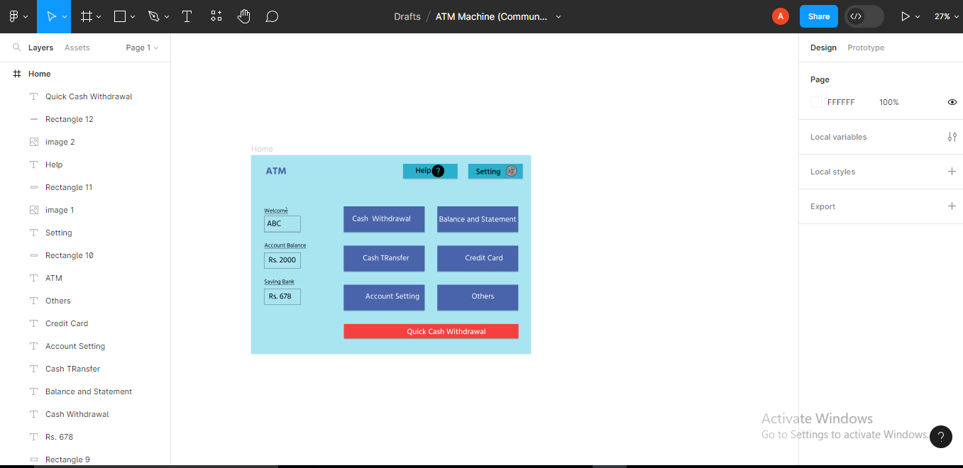

Practical 9 : Calculator using Figma

